**AI vs AI CAPTCHA – Next-Gen Cybersecurity Solution**

**1. Why AI CAPTCHA is Needed?**

**The Problem with Traditional CAPTCHAs**

* CAPTCHAs were designed to **differentiate humans from bots** by using challenges like text recognition, image selection, and logic puzzles.
* However, **modern AI models can solve CAPTCHAs with over 99.8% accuracy**, rendering them ineffective.
* **Security Threats:**
  + **Bots bypass CAPTCHAs**, leading to fraud, spam, and cyberattacks.
  + **User frustration** due to complex or unreadable CAPTCHAs.
  + **Revenue loss** for businesses as users abandon websites due to CAPTCHA failures.

**Why AI-Powered CAPTCHA?**

* **AI vs AI model** ensures CAPTCHAs continuously evolve against AI-based attacks.
* **Adaptive difficulty** makes it easy for humans but unpredictable for bots.
* **Seamless user experience** by integrating behavioral analysis, image, text, and logic-based verification.

**2. How AI vs AI CAPTCHA Works?**

**Traditional CAPTCHA vs. AI CAPTCHA**

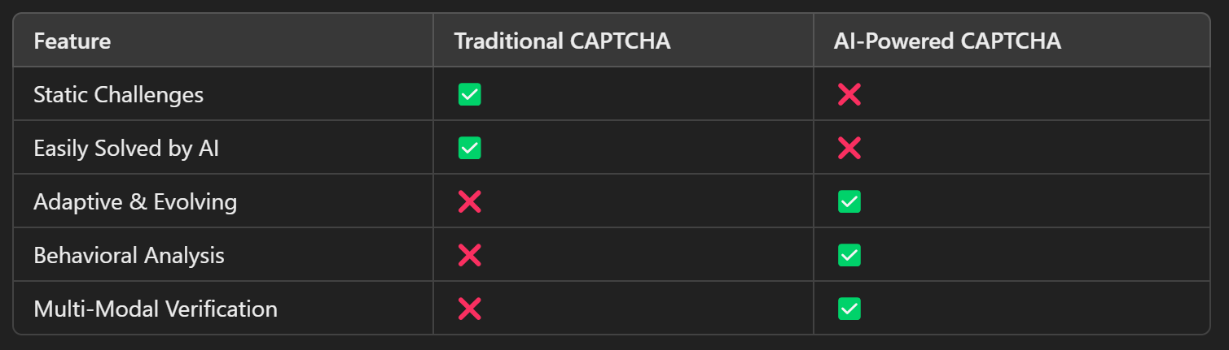

**AI vs AI Model – The Core Concept**

1. **Attacker AI (Bot Solver):**
   * Uses machine learning to **break CAPTCHAs** using advanced AI techniques.
   * Continuously learns from past CAPTCHA solutions.
2. **Defender AI (CAPTCHA Generator):**
   * **Analyzes bot behavior** and generates dynamic, unpredictable challenges.
   * Uses reinforcement learning to **adapt and improve** over time.
3. **Real-Time Adaptation:**
   * The CAPTCHA evolves whenever it detects an AI breaking it.
   * **Multi-modal verification** (text, images, behavioral analysis, logic puzzles) ensures security.
   * **Human-like behavior tracking** (mouse movements, typing speed) helps in user verification.

**Advantages Over Old CAPTCHAs**

✔ **Unbreakable by AI bots** – Evolving security system.  
✔ **Minimal user friction** – Faster, seamless verification.  
✔ **Scalable for any industry** – E-commerce, banking, cybersecurity, etc.

**3. Business Model – Monetizing AI CAPTCHA**

**Revenue Streams**

**1️⃣ SaaS Subscription Model (Security-as-a-Service)**

* **Monthly/Annual fees** for using the CAPTCHA API.
* **Pricing Tiers:**
  + **Basic (Free)** – Limited CAPTCHA requests.
  + **Pro ($X/month)** – AI-adaptive CAPTCHA for businesses.
  + **Enterprise (Custom Pricing)** – Advanced security solutions for large companies.

**2️⃣ Pay-Per-Use Model**

* High-traffic platforms pay **per 1,000 CAPTCHA verifications.**
* Ideal for **e-commerce, banking, and government portals.**

**3️⃣ Enterprise Licensing & White-Label Solutions**

* Large corporations and cybersecurity firms **license AI CAPTCHA** for their platforms.
* One-time **setup fees** + ongoing maintenance contracts.

**4️⃣ Freemium Model (Grow User Base, Upsell Premium Features)**

* **Basic CAPTCHA is free** for developers to integrate.
* **Premium AI security features & analytics** are paid add-ons.

**5️⃣ Security Consulting & Custom Implementations**

* Tailor-made CAPTCHA solutions for **high-security industries** (finance, healthcare, defense).

**Market Potential & Scalability**

💰 **Global CAPTCHA Security Market:** **$1+ Billion and growing!**  
🚀 **Potential Clients:**

* 🌐 **Websites & Apps** – Protect logins, forms, and sensitive data.
* 🏦 **Banks & E-commerce** – Prevent fraud & account takeovers.
* 🏢 **Government & Enterprises** – Secure confidential portals.
* 🔐 **Cybersecurity Firms** – White-label AI CAPTCHA solutions.

**Conclusion**

* AI vs AI CAPTCHA **evolves in real-time**, making it the **future of online security**.
* Unlike traditional CAPTCHAs, it is **adaptive, user-friendly, and scalable**.
* **Businesses can protect their platforms** while ensuring **a seamless user experience**.
* **With a billion-dollar market opportunity**, AI-powered CAPTCHA is a **game-changer in cybersecurity.**